Describe Cloud Concepts (20-25%)Identify the benefits and considerations of using cloud services

·identify the benefits of cloud computing, such as High Availability, Scalability, Elasticity, Agility, and Disaster Recovery

·identify the differences between Capital Expenditure (CapEx) and Operational Expenditure (OpEx)

·describe the consumption-based model-

Describe the differences between categories of cloud services

·describe the shared responsibility model

·describe Infrastructure-as-a-Service (IaaS),

·describe Platform-as-a-Service (PaaS)

·describe serverless computing

·describe Software-as-a-Service (SaaS)

·identify a service type based on a use case

Describe the differences between types of cloud computing

·define cloud computing

·describe Public cloud

·describe Private cloud

·describe Hybrid cloud

·compare and contrast the three types of cloud computing

Describe Core Azure Services (15-20%)Describe the core Azure architectural components

·describe the benefits and usage of Regions and Region Pairs

·describe the benefits and usage of Availability Zones

·describe the benefits and usage of Resource Groups

·describe the benefits and usage of Subscriptions

·describe the benefits and usage of Management Groups

·describe the benefits and usage of Azure Resource Manager

·explain Azure resources

What are the azure region pairs?

A **regional pair** consists of two **regions** within the same geography. **Azure** serializes platform updates (planned maintenance) across **regional pairs**, ensuring that only one **region** in each **pair** updates at a time. If an outage affects multiple **regions**, at least one **region** in each **pair** will be prioritized for recovery.

What are azure regions?

A **region** is a set of datacenters deployed within a latency-defined perimeter and connected through a dedicated regional low-latency network. **Azure** gives you the flexibility to deploy applications where you need to, including across multiple **regions** to deliver cross-**region** resiliency.

What is GRS in Azure?

**Azure** Storage offers two options for copying your data to a secondary region: Geo-redundant storage (**GRS**) copies your data synchronously three times within a single physical location in the primary region using LRS. It then copies your data asynchronously to a single physical location in the secondary region

What is azure DCE?

Unlike traditional cloud solutions **DCE Azure** Managed Cloud Services provide a complete cloud application management layer, DevOps and solution support so that you can 100% focus on your core business.

What is Azure Germany?

**Azure Germany** is a physically isolated instance of Microsoft **Azure** that uses world-class security and compliance services that are critical to **German** data privacy regulations.

What VPN types are supported by Azure?

**The following cross-premises connections are supported:**

* Site-to-Site – **VPN connection** over **IPsec** (IKE v1 and IKE v2). ...
* **Point**-to-Site – **VPN connection** over SSTP (Secure Socket Tunneling Protocol) or IKE v2. ...
* **VNet**-to-**VNet** – This type of **connection** is the same as a Site-to-Site configuration.

Are multiple Azure Portal dashboards supported in Azure?

* You can create **multiple dashboards** in the **Azure portal** that each include tiles visualizing data from **multiple Azure** resources across different resource groups and subscriptions.

What is Azure replication?

**Replication** to **Azure** eliminates the cost and complexity of maintaining a secondary datacenter. Workload **replication**. **Replicate** any workload running on supported **Azure** VMs, on-premises Hyper-V and VMware VMs, and Windows/Linux physical servers.

What is azure calculator?

**Azure** Cost **Calculator** is a free cost management tool that can help you estimate your cloud costs for new **Azure** deployments, or variations of your existing workloads.

What is azure advisor?

**Azure Advisor** analyses your configurations and usage telemetry and offers personalised, actionable recommendations to help you optimise your **Azure** resources for reliability, security, operational excellence, performance and cost.

Is ExpressRoute a VPN?

We use industry standard IPsec **VPN** in Azure. ... **ExpressRoute ExpressRoute** lets you create private connections between Azure datacenters and infrastructure that's on your premises or in a co-location environment.

Are Azure services in private preview available to all customers?

As part of the beta testing process, you can also provide feedback to Microsoft, which is used to improve **Azure**. ... The **private preview** is only **available** to certain **Azure customers** for evaluation purposes. The public **preview** is **available to all Azure customers**.

What is disaster recovery in Azure?

**Azure** is the first public cloud to offer native **Disaster Recovery** solution for applications running on IaaS. With this offering, you can make your applications resilient to even region level failures by replicating VMs into another region.

What is fault tolerance in Azure?

Database **Fault**-**Tolerance** in a Nutshell  
If any component fails on the primary replica, Windows **Azure** SQL Database detects the failure and fails over to the secondary replica. ... Other than the loss of an entire data center all other failures are mitigated by the service.

What is RTO information technology?

Recovery Time Objective (**RTO**) **RTO** refers to how much time an interruption can last for any business function – this often involves **information technology** software or hardware – before the business is adversely affected in terms of loss of money or reputation.

What is TCO in cloud?

**Total cost of ownership**, or **TCO**, is a formula that assesses direct and indirect costs and benefits related to the purchase of any IT component.

Does Azure have a firewall?

**Azure Firewall** is a managed, cloud-based network security service that protects your **Azure** Virtual Network resources. It's a fully stateful **firewall** as a service with built-in high availability and unrestricted cloud scalability. ... The service is fully integrated with **Azure** Monitor for logging and analytics

What is azure Eventhub?

**Azure Event Hubs** is a big data streaming platform and event ingestion service. It can receive and process millions of events per second. Data sent to an **event hub** can be transformed and stored by using any real-time analytics provider or batching/storage adapters.

What is azure CLI used for?

The **Azure command-line** interface (**Azure CLI**) is a set of commands **used** to create and manage **Azure** resources. The **Azure CLI** is available across **Azure** services and is designed to get you working quickly with **Azure**, with an emphasis on automation.

What is DNS in Azure?

**Azure DNS** is a hosting service for **DNS** domains that provides name resolution by using Microsoft **Azure** infrastructure. By hosting your domains in **Azure**, you can manage your **DNS** records by using the same credentials, APIs, tools, and billing as your other **Azure** services. You can't use **Azure DNS** to buy a domain name.

What is VPN Gateway?

A **VPN gateway** is a specific type of virtual network **gateway** that is used to send encrypted traffic between an Azure virtual network and an on-premises location over the public Internet. ... Each virtual network can have only one **VPN gateway**. However, you can create multiple connections to the same **VPN gateway**.

How do I make Azure VPN?

1. Prerequisites. An **Azure** account with an active subscription. ...
2. **Create** a **virtual network**. **Create** a **virtual network** (VNet) using the following values: ...
3. **Create** a **VPN** gateway. ...
4. **Create** a local network gateway. ...
5. Configure your **VPN** device. ...
6. **Create** a **VPN** connection. ...
7. Verify the **VPN** connection. ...
8. Connect to a virtual machine.

Is ExpressRoute a MPLS?

With **ExpressRoute**, establish connections to Azure at an **ExpressRoute** location, such as an Exchange provider facility, or directly connect to Azure from your existing WAN network, such as a multiprotocol label switching (**MPLS**) VPN, provided by a network service provider.

What is ExpressRoute VPN Azure?

Once a site-to-site **VPN** is setup you have IP level connectivity between your premises and virtual networks in **Azure**. ...

**ExpressRoute** lets you create private connections between **Azure** datacenters and infrastructure that's on your premises or in a co-location environment

What is ExpressRoute direct?

**ExpressRoute Direct** gives you the ability to connect **directly** into Microsoft's global network at peering locations strategically distributed across the world. **ExpressRoute Direct** provides dual 100 Gbps or 10 Gbps connectivity, which supports Active/Active connectivity at scale.

Can Azure VNet span availability zones?

Subnet – For effective design and control of resources deployed on the cloud, both **Azure VNet** and AWS VPC segregate the networks with subnets.

An AWS VPC **spans** all the **Availability Zones** (AZs) in that region, hence, subnets in AWS VPC are mapped to **Availability Zones** (AZs).

What is availability set in Azure?

An **Availability Set** is a logical grouping capability for isolating VM resources from each other when they're deployed. **Azure** makes sure that the VMs you place within an **Availability Set** run across multiple physical servers, compute racks, storage units, and network switches.

What is the difference between availability zone and region?

Each **Region** is a separate geographic area. **Availability Zones** are multiple, isolated locations within each **Region**. Local **Zones** provide you the ability to place resources, such as compute and storage, in multiple locations closer to your end users.

What is a Policy Definition? A policy definition expresses what to **evaluate** and what **action to take**. For example, you could ensure all public websites are secured with HTTPS, prevent a particular storage type from being created, or force a specific version of SQL Server to be used.

What does it mean if a service is in private preview mode?

**What does it mean if a service is in Private Preview mode**? ... Anyone can use the **service** but it must not be for production use. Anyone can use the **service** for any reason. The **service** is generally available for use, and Microsoft will provide support for it.

What is difference between RTO and RPO?

When there is a system outage, the **RPO** and **RTO** are two data points that can tell you how seriously the downtime has impacted a customer's business operations: Recovery Point Objective (**RPO**) is a measure of how frequently you take backups. ... Recovery Time Objective (**RTO**) is the amount of downtime a business can tolerate.

What is soft delete in Azure?

When turned on, **soft delete** enables you to save and recover your data where blobs or blob snapshots are **deleted**. ... This protection extends to blob data that is erased as the result of an overwrite.

How do you calculate TCO?

**The next time you are selecting new equipment, try using the total cost of ownership (TCO) formula:**

1. I = Initial cost. The initial cost is the number that appears on the price tag. ...
2. O = Operation. ...
3. M = Maintenance. ...
4. D = Downtime. ...
5. P = Production. ...
6. R = Remaining value.

Is Azure firewall Layer 7?

There is no shortage of **firewall** options in **Azure** for network security at the transport (**Layer**-4) and application (**Layer**-**7**) **layers** of the network stack. The foundational component is the free networks security group (NSG), providing allow/deny filtering for TCP/UDP traffic

Is Azure NSG stateful?

The NSGs in **Azure** are **Stateful**. ... Meaning that if you open an incoming port, the outgoing port will be open automatically to allow the traffic. The default rules in a **Network Security Group** allow for outbound access and inbound access is denied by default.

What is the difference between Azure firewall and NSG?

An **NSG** is a **firewall**, albeit a very basic one. It's a software defined solution that filters traffic at the Network layer. However, **Azure Firewall** is more robust. It's a managed **firewall** service that can filter and analyze L3-L4 traffic, as well as L7 application traffic.

Is Azure event hub Kafka?

With **Azure Event Hubs** for Apache **Kafka**, we're bringing together two powerful distributed streaming platforms so you can access the breadth of **Kafka** ecosystem applications without having to manage servers or networks. **Event Hubs** is a fully managed, real-time data ingestion service that's simple, trusted, and scalable.

What is azure Databricks?

**Azure Databricks** is a data analytics platform optimized for the **Microsoft Azure** cloud services platform. ...

For a big data pipeline, the data (raw or structured) is ingested into **Azure** through **Azure** Data Factory in batches, or streamed near real-time using Apache Kafka, Event Hub, or IoT Hub.

What is Eventgrid?

Simplify your event-based apps with **Event Grid**, a single service for managing routing of all events from any source to any destination.

Designed for high availability, consistent performance, and dynamic scale, **Event Grid** lets you focus on your app logic rather than infrastructure.

Why should we use Azure CLI?

Because installing it on your local computer allows greater control, **better** typing experience, an environment and shell you can customize to your liking, etc.

You can install **Azure CLI** on Mac, Windows, or Linux. Or, if you prefer, you can even run it as a Docker image.

Is Azure CLI PowerShell?

**Azure CLI** is a **PowerShell**-like-tool available for all platforms. You can use the same commands no matter what platform you use: Windows, Linux or Mac. ... js to achieve cross-platform capabilities, and the new **Azure CLI** 2.0 is written in Python to offer better cross-platform capabilities.

How does Azure CLI work?

**Azure CLI** is a cross-platform **command** line tool, that is used to manage and administrate Microsoft **Azure**. It doesn't replace PowerShell but provides an alternative to using managing **Azure** from the **command** line. You can still continue using PowerShell, the APIs, and the **Azure** Portal just like before.

What is DNS zone example?

**DNS** Root **Zone**  
The root of the **DNS** system, represented by a dot at the end of the domain name—for **example**, www.**example**.com. —is the primary **DNS zone**.

What is Azure CDN?

**Azure** Content Delivery Network (**CDN**) lets you reduce load times, save bandwidth and speed responsiveness—whether you are developing or managing websites or mobile apps or encoding and distributing streaming media, gaming software, firmware updates or IoT endpoints.

How do I access my Azure DNS?

**To test DNS name resolution:**

1. In the **Azure** portal, under All resources, open the contoso. xyz **DNS** zone in the MyResourceGroup resource group. ...
2. Copy one of the name server names from the name server list on the Overview page.
3. Open a command prompt, and run the following command: nslookup www.contoso.xyz <name server name>

How do I find my VPN gateway?

**How to Find Default Gateway IP Address on Android?**

1. Tap Settings.
2. Tap Wi-Fi.
3. Long tap **your** network connection.
4. Tap Modify network.
5. Tap Advanced options.
6. Switch the IPv4 settings to Static.
7. **Find your gateway** IP address listed next to **Gateway**.

How does Azure VPN Work?

A **VPN** gateway **is** a type of **virtual network** gateway. A **VPN** gateway sends encrypted traffic between your **virtual network** and your on-premises location across a public connection. You **can** also use a **VPN** gateway to send traffic between virtual networks. When you create a **VPN** gateway, you use the -GatewayType value '**Vpn**'.

What is ExpressRoute?

**ExpressRoute** is a service that enables you to create private connections between Azure datacenters and infrastructure that's on your premises or in a colocation environment.

How does Azure ExpressRoute work?

An **ExpressRoute** circuit, once set up, allows you to access services within a virtual network and other **Azure** services simultaneously.

You connect to virtual networks over the private peering path, and to other services over the **Microsoft** peering path.

Is Azure ExpressRoute encrypted?

**ExpressRoute** supports a couple of **encryption** technologies to ensure confidentiality and integrity of the data traversing between your network and **Microsoft's** network.

What is an Azure gateway?

**Azure** **Application** **Gateway** is a web traffic load balancer that enables you to manage traffic to your web applications. ... This type of routing is known as application layer (OSI layer 7) load balancing. **Azure** Application **Gateway** can do URL-based routing and more

What is Azure private link?

**Azure Private Link** provides **private** connectivity from a virtual network to **Azure** platform as a service (PaaS), customer-owned, or Microsoft partner services. It simplifies the network architecture and secures the connection between endpoints in **Azure** by eliminating data exposure to the public internet.

What is Azure connection?

**Azure** Virtual Network (VNet) is the fundamental building block for your private network in **Azure**. You can use a VNets to: ... Communicate with on-premises networks: You can **connect** your on-premises computers and networks to a virtual network using VPN Gateway or ExpressRoute.

Does Azure supports availability zones in all regions?

**Availability Zones** are unique physical locations within an **Azure region**. Each **zone is** made up of one or more datacenters equipped with independent power, cooling, and networking. To ensure resiliency, there's a minimum of three separate **zones in all** enabled **regions**.

What are subnets in Azure?

A **subnet** is a range of IP addresses in the VNet. You can divide a VNet into multiple **subnets** for organization and security. Each NIC in a VM is connected to one **subnet** in one VNet. NICs connected to **subnets** (same or different) within a VNet can communicate with each other without any extra configuration.

What is difference between VNet and subnet?

A **VNET** is the address space. It hosts **subnet**, where you will connect resources.

**Subnet** segment the address space into multiple subnetworks.

By default, an IP **in a subnet** can communicate with any other IP inside the **VNET**.

What are fault domains in Azure?

**Fault domains** define the group of virtual machines that share a common power source and network switch. By default, the virtual machines configured within your availability set are separated across up to three **fault domains** for Resource Manager deployments (two **fault domains** for Classic).

What is GA in Azure?

@dfw-dba **GA** means Generally Available. Any **Azure** service is first made available as a Preview and all the issues are corrected in the preview and then made generally available.

Are Azure services in private preview available to all customers?

As part of the beta testing process, you can also provide feedback to Microsoft, which is used to improve **Azure**. ...

The **private preview** is only **available** to certain **Azure customers** for evaluation purposes. The public **preview** is **available to all Azure customers**.

How does Azure migrate work?**

**Azure Migrate** is a **Microsoft** service that helps an enterprise assess how its on-premises workloads will perform, and how much they will cost to host, in the **Azure** public cloud.

While **Azure Migrate** helps with planning a cloud **migration**, it **does** not actually transfer on-premises virtual machines (VMs) to the **Azure** cloud.

What software is used to synchronize your on premises ad with your Azure AD?

**Azure AD Connect** is a tool that connects functionalities of its two predecessors – **Windows Azure** Active Directory Sync, commonly referred to as **DirSync**,

and Azure AD Sync (AAD Sync)

Describe core resources available in Azure

·describe the benefits and usage of Virtual Machines, Azure App Services, Azure Container Instances (ACI), Azure Kubernetes Service (AKS), and Windows Virtual Desktop

·describe the benefits and usage of Virtual Networks, VPN Gateway, Virtual Network peering, and ExpressRoute

·describe the benefits and usage of Container (Blob) Storage, Disk Storage, File Storage, and storage tiers

·describe the benefits and usage of Cosmos DB, Azure SQL Database, Azure Database for MySQL, Azure Database for PostgreSQL, and SQL Managed Instance

·describe the benefits and usage of Azure Marketplace

Describe core solutions and management tools on Azure (10-15%)

Describe core solutions available in Azure

·describe the benefits and usage of Internet of Things (IoT) Hub, IoT Central, and Azure Sphere

·describe the benefits and usage of Azure Synapse Analytics, HDInsight, and Azure Databricks

·describe the benefits and usage of Azure Machine Learning, Cognitive Services and Azure Bot Service

·describe the benefits and usage of serverless computing solutions that include Azure Functions and Logic Apps

·describe the benefits and usage of Azure DevOps, GitHub, GitHub Actions, and Azure DevTest LabsDescribe Azure management tools

·describe the functionality and usage of the Azure Portal, Azure PowerShell, Azure CLI, Cloud Shell, and Azure Mobile App

·describe the functionality and usage of Azure Advisor

·describe the functionality and usage of Azure Resource Manager (ARM) templates

·describe the functionality and usage of Azure Monitor

·describe the functionality and usage of Azure Service Health

Describe general security and network security features (10-15%)Describe Azure security features

·describe basic features of Azure Security Center, including policy compliance, security alerts, secure score, and resource hygiene

·describe the functionality and usage of Key Vault

·describe the functionality and usage of Azure Sentinel

·describe the functionality and usage of Azure Dedicated HostsDescribe Azure network security

·describe the concept of defense in depth

·describe the functionality and usage of Network Security Groups (NSG)

·describe the functionality and usage of Azure Firewall

·describe the functionality and usage of Azure DDoS protection

Describe identity, governance, privacy, and compliance features (20-25%)

Describe core Azure identity services

·explain the difference between authentication and authorization

·define Azure Active Directory

·describe the functionality and usage of Azure Active Directory

·describe the functionality and usage of Conditional Access, Multi-Factor Authentication (MFA), and Single Sign-On (SSO)Describe Azure governance features

·describe the functionality and usage of Role-Based Access Control (RBAC)·describe the functionality and usage of resource locks·describe the functionality and usage of tags

·describe the functionality and usage of Azure Policy

·describe the functionality and usage of Azure Blueprints

·describe the Cloud Adoption Framework for AzureDescribe privacy and compliance resources

·describe the Microsoft core tenets of Security, Privacy, and Compliance

·describe the purpose of the Microsoft Privacy Statement, Online Services Terms (OST) and Data Protection Amendment (DPA)

·describe the purpose of the Trust Center

·describe the purpose of the Azure compliance documentation

·describe the purpose of Azure Sovereign Regions (Azure Government cloud services and Azure China cloud services)

Describe Azure cost management and Service Level Agreements (10-15%)

Describe methods for planning and managing costs

·identify factors that can affect costs (resource types, services, locations, ingress and egress traffic)

·identify factors that can reduce costs (reserved instances, reserved capacity, hybrid use benefit, spot pricing)

·describe the functionality and usage of the Pricing calculator and the Total Cost of Ownership (TCO) calculator

·describe the functionality and usage of Azure Cost ManagementDescribe Azure Service Level Agreements (SLAs) and service lifecycles

·describe the purpose of an Azure Service Level Agreement (SLA)

·identify actions that can impact an SLA (i.e. Availability Zones)

·describe the service lifecycle in Azure (Public Preview and General Availability

Microsoft Azure provides several different ways to host and execute code or workflows without using Virtual Machines (VMs) including

Azure Functions,

Microsoft Power Automate, Design-First

Azure Logic Apps, Design-First

Azure WebJobs

These four technologies have some similarities. For example:

* They can all accept **inputs**. An input is a piece of data or a file that is supplied to the workflow.
* They can all run **actions**. An action is a simple operation that the workflow executes and may often modify data or cause another action to be performed.
* They can all include **conditions**. A condition is a test, often run against an input, that may decide which action to execute next.
* They can all produce **outputs**. An output is a piece of data or a file that is created by the workflow.

Workflows created with these technologies can either start based on a schedule or they can be triggered by some external event.

**Design-First Approach**

With Logic Apps and Microsoft Power Automate, you can take a similar approach to designing a workflow.

They both include user interfaces in which you can draw out the workflow. We call this approach a design-first approach.

**Logic Apps** 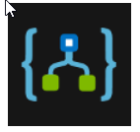

[Logic Apps](https://azure.microsoft.com/services/logic-apps/) is a service within Azure that you can use to **automate, orchestrate, and integrate disparate components of a distributed application.** By using the design-first approach in Logic Apps, you can **draw out complex workflows that model complex business processes**. The following screenshot shows the Logic Apps Designer and design canvas that you use to define your workflow.

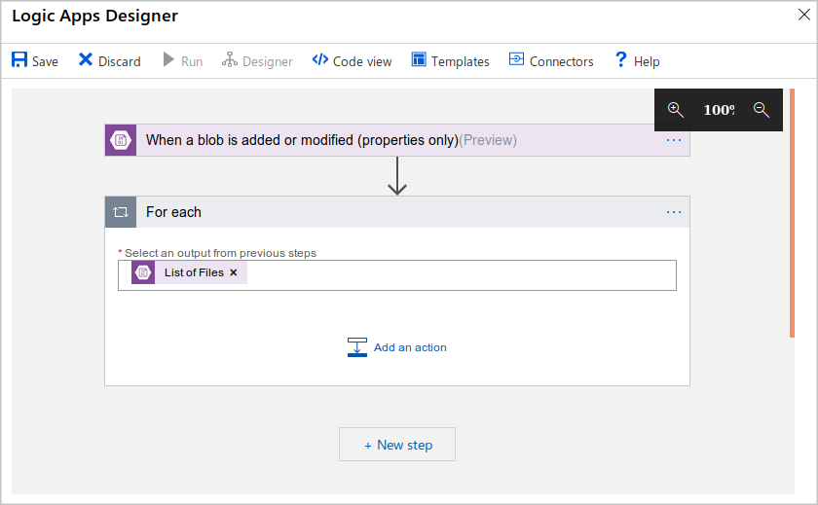 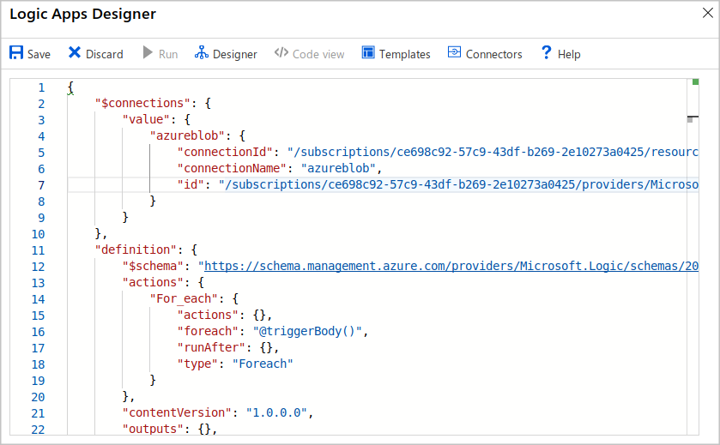

[Over 200 connectors are included](https://docs.microsoft.com/en-us/connectors/connector-reference/). A **connector** is a Logic Apps component that provides an interface to an external service.

**Microsoft Power Automate** 

Microsoft [Power Automate](https://flow.microsoft.com/) is a service that you can use to create workflows even when you have no development or IT Pro experience. You can create workflows that integrate and orchestrate many different components by using the website or the Microsoft [Power Automate mobile app](https://flow.microsoft.com/mobile/download/).

There are four different types of flow that you can create:

* **Automated**: A flow that is started by a trigger from some event. For example, the event could be the arrival of a new tweet or a new file being uploaded.
* **Button**: Use a button flow to run a repetitive task with a single click from your mobile device.
* **Scheduled**: A flow that executes on a regular basis such as once a week, on a specific date, or after 10 hours.
* **Business process**: A flow that models a business process such as the stock ordering process or the complaints procedure. The flow process can have: notification to required people; with their approval recorded; calendar dates for steps; and recorded time of flow steps.

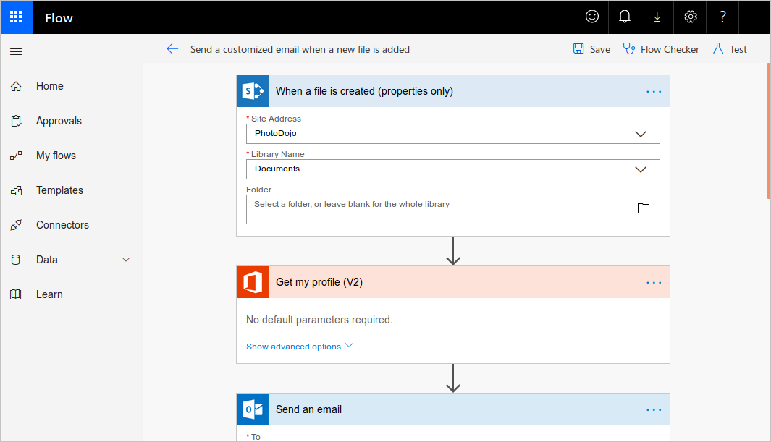

Under the hood, Microsoft Power Automate is built on Logic Apps. This fact means that Power Automate [supports the same range of connectors and actions](https://flow.microsoft.com/connectors/). You can also use [custom connectors](https://docs.microsoft.com/en-us/power-automate/get-started-flow-dev) in Microsoft Power Automate.

**Design-first technologies compared**

As you can see from the following table, Microsoft Power Automate is more appropriate for use by non-technical staff. If your workflow designers are IT professionals, developers, or DevOps practitioners, Logic Apps are usually a better fit:

| **Design-first technologies compared** | | |
| --- | --- | --- |
|  | **Microsoft Power Automate** | **Logic Apps** |
| **Intended users** | Office workers and business analysts | Developers and IT pros |
| **Intended scenarios** | Self-service workflow creation | Advanced integration projects |
| **Design tools** | GUI only. Browser and mobile app | Browser and Visual Studio designer. Code editing is possible |
| **Application Lifecycle Management** | Power Automate includes testing and production environments | Logic Apps source code can be included in Azure DevOps and source code management systems |

## **Code-first technologies**

### WebJobs and the WebJobs SDK

The [Azure App Service](https://azure.microsoft.com/services/app-service/) is a cloud-based hosting service for web applications, mobile back-ends, and RESTful APIs. These applications often need to perform some kind of background task. For example, in your bike rental system, when a user uploads a photo of a bike, you may need to generate a smaller thumbnail photograph.

[WebJobs](https://docs.microsoft.com/en-us/azure/app-service/webjobs-create) are a part of the Azure App Service that you can use to run a program or script automatically. There are two kinds of WebJob:

* **Continuous.** These WebJobs run in a continuous loop. For example, you could use a continuous WebJob to check a shared folder for a new photo.
* **Triggered.** These WebJobs run when you manually start them or on a schedule.

To determine what actions your WebJobs takes, you can write code in several different languages. For example, you can script the WebJob by writing code in a Shell Script (Windows, PowerShell, Bash). Alternatively, you can write a program in PHP, Python, Node.js, or JavaScript. These WebJOBS do have a limitations, using ASP.NET / SDK 2.x; however SDK 3.x supports .NET Core.

You can also program a WebJob by using the .NET Framework or the .NET Core Framework and a .NET language such as C# or VB.NET. In this case, you can also use the WebJobs SDK to make the task easier. The SDK includes a range of classes, such as JobHostConfiguration and HostBuilder, which reduce the amount of code required to interact with the Azure App Service.

The WebJobs SDK only supports C# and the NuGet package manager.

### Azure Functions

### An [Azure Function](https://azure.microsoft.com/services/functions/) is a simple way for you to run small pieces of code in the cloud, without having to worry about the infrastructure required to host that code. You can write the Function in C#, Java, JavaScript, PowerShell, Python, or any of the languages that are listed in the [Supported languages in Azure Functions](https://docs.microsoft.com/en-us/azure/azure-functions/supported-languages) article. In addition, with the consumption plan option, you only pay for the time when the code runs. Azure automatically scales your function in response to the demand from users.

### When you create an Azure Function, you can start by writing the code for it in the portal. Alternatively, if you need source code management, you can use GitHub or Azure DevOps Services.

To create an Azure Function, choose from the range of templates. **HTTPTrigger**. Use this template when you want the code to execute in response to a request sent through the HTTP protocol.

* **TimerTrigger**. Use this template when you want the code to execute according to a schedule.
* **BlobTrigger**. Use this template when you want the code to execute when a new blob is added to an Azure Storage account.
* **CosmosDBTrigger**. Use this template when you want the code to execute in response to new or updated documents in a NoSQL database.

Azure Functions can integrate with many different services both within Azure and from third parties. These services can trigger your function, or send data input to your function, or receive data output from your function.

### Code-first technologies compared

In most cases, the simple administration and more flexible coding model provided by Azure Functions may lead you to choose them in preference to WebJobs. However, you may choose WebJobs for the following reasons:

* You want the code to be a part of an existing App Service application and to be managed as part of that application, for example in the same Azure DevOps environment.
* You need close control over the object that listens for events that trigger the code. This object in question is the JobHost class, and you have more flexibility to modify its behavior in WebJobs.

| Code-first technologies compared | | |
| --- | --- | --- |
|  | **Azure WebJobs** | **Azure Functions** |
| Supported languages | C# if you are using the WebJobs SDK | C#, Java, JavaScript, PowerShell, etc. |
| Automatic scaling | No | Yes |
| Development and testing in a browser | No | Yes |
| Pay-per-use pricing | No | Yes |
| Integration with Logic Apps | No | Yes |
| Package managers | NuGet if you are using the WebJobs SDK | Nuget and NPM |
| Can be part of an App Service application | Yes | No |
| Provides close control of JobHost | Yes | No |

## **How to choose a service**

### Diagram of decision flow chart that will be described in depth in the text that follows.

The first question to ask is whether you prefer to design the workflow in a GUI designer tool or by writing code.

**The following list has some valid reasons for using a design-first tool:**

* **People who design the workflow have no coding experience.**
* **Later designers and users can consult the graphical design to clearly understand how the workflow proceeds.**

**Alternatively, you can choose to use a code-first tool because:**

* **People who design the workflow are developers and prefer to work entirely in code.**
* **You want the details of a workflow to be hidden from non-coders.**

There are **two situations in which WebJobs might be a better choice**:

* You have an existing Azure App Service application, and you want to model the workflow within the application. This requirement means that the workflow can also be managed as part of the application, for example in an Azure DevOps environment.
* You have specific customizations that you want to make to the JobHost that are not supported by Azure Functions. For example, in a WebJob, you can create a custom retry policy for calls to external systems. This kind of policy can't be configured in an Azure Function.
* Webjobs only supports C# on Microsoft Windows.

## What is Azure Functions?

Azure Functions is a serverless application platform. It allows developers to host business logic that can be executed without provisioning infrastructure. Functions provides intrinsic scalability and you are charged only for the resources used. You can write your function code in the language of your choice, including C#, F#, JavaScript, Python, and PowerShell Core. Support for package managers like NuGet and NPM is also included, so you can use popular libraries in your business logic.

## What is serverless compute?

[Serverless compute](https://azure.microsoft.com/solutions/serverless/) can be thought of as a function as a service (FaaS), or a microservice that is hosted on a cloud platform. Your business logic runs as functions and you don't have to manually provision or scale infrastructure. The cloud provider manages infrastructure. Your app is automatically scaled out or down depending on load. Azure has several ways to build this sort of architecture. The two most common approaches are Azure Logic Apps and Azure Functions, which we focus on in this module.

**When to choose Azure Functions to run your business logic**

The following factors will influence your choice:

* Cost: With Web Jobs, you pay for the entire VM or App Service Plan that hosts the job. Azure Function can run on a consumption plan, so you only pay when the function runs. Since this process only kicks off when a bike is returned, we might stand to save by selecting Azure Functions.
* Integrations: You want to integrate the maintenance workflow with the Logic App that you build for the bike booking and rental process in the previous unit. Although it is possible to call a WebJob from a Logic App, the integration between Logic Apps and Functions is closer. For example, you can more easily control your call to a Function from the Logic Apps designer.

For these reasons, we'll select Azure Function to manage your bike maintenance business process.

## Benefits of a serverless compute solution

### -Avoids over-allocation of infrastructure

### -Stateless logic

### -Event driven

### -Functions can be used in traditional compute environments

## Drawbacks of a serverless compute solution

### -Execution time

### -Execution frequency